|  |
| --- |
| Project Code: **COFUND-CETP-CTS**  **Contract no 37 of 1/03/2024**  **Name of the Program in PN IV:**  **5.8 - European and International Cooperation Programme . 5.8.1 - Horizon Europe Sub-programme European Partnerships and Missions (institutionalised and co-funded partnerships)** |
| Project Acronym:  **CTS** |
| Project Title:  **CO2 Transport and Storage directly from a ship: flexible and cost-effective solutions for European offshore storage** |
| Project start date: 01.03.2024  Duration: 21 months |
| **REPORT – PHASE I, 2024**  **Defining the Case study for Romania**  **Summary** |
| Contractor: |
| The National Institute for Research and Development on Marine Geology and Geo-ecology – GeoEcoMar |
|  |

**CONTENTS**

EXECUTIVE SUMMARY OF THE ACTIVITIES PERFORMED DURING THE IMPLEMENTATION PHASE....................................................................................................3

**SCIENTIFIC DESCRIPTION NOTING THE RESULTS OF THE ANNUAL PHASE AND THE DEGREE OF ACHIEVEMENT OF THE OBJECTIVES ...........................................................4**

1.1 CRITERIA FOR THE DESIGN OF THE CCS VALUE CHAIN USING SHIP INJECTION - CONTRIBUTIONS TO THE DEFINITION OF CRITERIA FOR THE SELECTION OF COMPONENTS OF THE CCS VALUE CHAIN........................................................................................................................................................................4

1.2 SELECTION OF CANDIDATES IN DIFFERENT GEOGRAPHICAL AREAS AND CREATION OF SCENARIOS (I) - DEFINITION OF THE ROMANIAN PRELIMINARY SCENARIO FOR THE IMPLEMENTATION OF CO2 INJECTION TECHNOLOGY DIRECTLY BY SHIP....................................................................................................6

1.3 ANALYSIS OF CCS VALUE CHAIN ​​IN DIFFERENT GEOGRAPHICAL AREAS (I) - PRELIMINARY ANALYSIS OF THE SELECTED CARBON CAPTURE AND STORAGE VALUE CHAIN ​​FOR ROMANIA.................................8

1.4 END-USER ENGAGEMENT ANALYSIS (I) – END-USERS MAPPING IN ROMANIA.......................................10

**Executive Summary of the Activities performed during the Implementation Phase**

During 2024, several activities were carried out in the first phase of the CTS project, all the objectives being achieved 100% and the all the expected results being obtained: the selection of the Romanian CCS value chain; preliminary analysis of the value chain of CCS in Romania and the mapping of the end users in Romania. The definition of the selection criteria of the components of the CCS value chains within the project was the first result of the project, the result on which the selection of the CCS value chain for Romania was also based upon.

GeoEcoMar had helped establish the specific selection criteria for value chain capture and storage components. For the capture component, the following criteria were selected: supply logistics (the selected emitters to be within 50 km of the existing ports and with good connectivity); CO2 value, the existence of plans or possibilities for future CCS implementation at the level of industrial operators.

For the storage component, the criteria applied were: the level of readiness for storage, access to storage, overlapping with other economic activities.

Applying the selected criteria, during this phase, we selected the Romanian CCS value chain. For the capture component, we selected large emitters from two clusters, Călărași and Constanța.

The Călărași cluster includes 2 emitters, a glass producer and a cast iron and steel producer. The Constanța cluster includes the Medgidia cement factory, a refinery, an electricity and heat producer, a lime producer and an energy producer. For transport, we considered multi-modal options involving river transport on the Danube, transport on the Danube-Black Sea canal, short pipeline connections from the industrial facilities to the nearby ports, and maritime transport from the ports to the offshore storage sites (3 options – pipeline, conventional vessels and direct injection vessels). For the storage component, we selected hydrocarbon depleting deposits (Lebăda Est, Lebăda Vest, Sinoe) and potential saline aquifers (Venus, Iris, Tomis, Lotus) as potential sites.

At the level of the entire Romanian CCS value chain, a preliminary analysis was made looking at the level of emissions, the components of the emitted gas flows, the possibility of including CCS in the decarbonization plans, the limitations regarding ship sizes, draught, the availability of port space for an intermediate storage hub installation prior to CO2 loading on ships, the properties of potential offshore CO2 reservoirs, storage capacities.

Another important result of the phase was the mapping of end users in Romania. It is worth mentioning that GeoEcoMar coordinated the regional mapping activity throughout the project and participated in the implementation of the user engagement strategy.

As part of this strategy and to verify the feasibility of the Romanian value chain, in addition to consultations with individual users, on November 14, GeoEcoMar organized a hybrid workshop, that was attended by representatives of transmitters, authorities, potential storage operators and non-governmental organizations.

As dissemination activities, at this phase of the project, GeoEcoMar team participated in 3 prestigious CCS conferences, CO2GeoNet Open Forum (21-22 May 2024), Baltic Carbon Forum (3-4 October 2024) and GHGT 17 (20-24 October 2024).

The project manager of GeoEcoMar was also the co-author of a poster presented by Ivan Virshylo (Naftogaz) at the AAPG Europe Regional Conference 2024 (May 28-29, 2024, Krakow). Based on the presentations made at these conferences, GeoEcoMar team is preparing two papers that will be submitted for publication at the end of this year.

Furthermore, the dissemination was also made to the general public through the LinkedIn social media platform of the project through short presentation films in which the person in charge of GeoEcoMar was also involved.

**Scientific Description noting the Results of the Annual Phase and the Degree of Achievment of the Objectives**

Criteria for the Design of the CCS Value Chain using Ship Injection - Contributions to the Definition of Criteria for the Selection of Components of the CCS Value Chain

Establishing the selection criteria for the components of the CCS value chains within the project was the first result of the project and it was debated during several scientific meetings.

This activity was carried out under work package 1 ”Criteria’s for designing value chain for CCS using ship Injection” and materialized through deliverable D1.1.Report on applicability criteria.

Several projects, such as Strategy CCUS, have recently analysed and developed criteria for the selection of emission and storage actors for the value chain. We tried to improve the structure of the criteria to see their interaction along the value chain and to highlight the specifics of each individual type of actors (see the figure below). This is a more systematized approach that should not only help with selection, but also in TEA/LCA and in cross-regional comparison later on.

Analyzing the value chain, there is a number of parameters that are common to all actors, while others are specific to each industrial activity, such as emiters, transport and storage. These are shown in Figure 1.

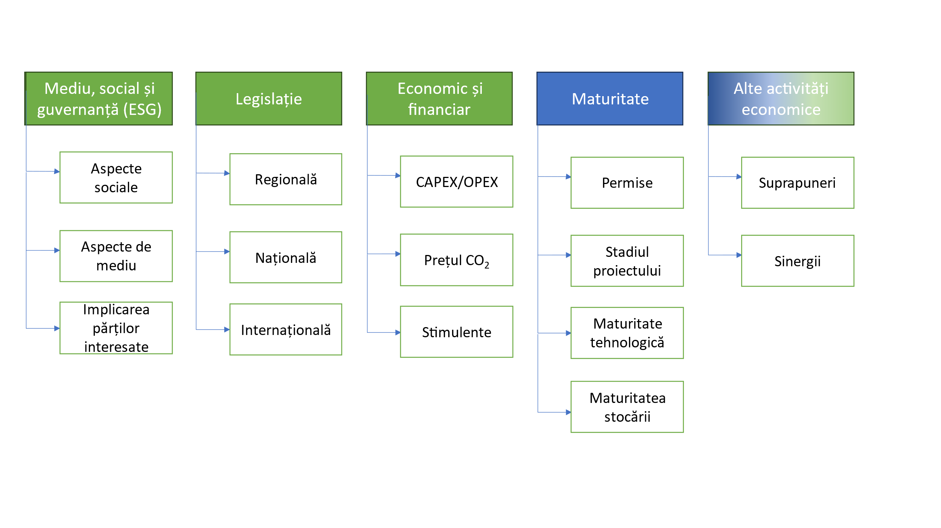

**Figure 1. Common parameters of the value chain**

The parameters marked in green (Figure 1) are the external parameters, while maturity is an internal parameter. However, several of the parameters can be classified as both external and internal. Overlapping with other economic activities can be both an external, i.e. other activities and/or operators in the area, and an internal parameter, such as CO2 utilization plans. CAPEX and OPEX also cover both areas, where component costs and minimum wages are external factors, while cost optimization is controlled by the project.

Environmental, social and governance factors are also both external, such as, for example, the general attitude towards CCS in society, as well as internal, where the individual participants or the value chain as a whole can (and should) address existing problems.

Each of the parameters in Figure 1 has a different global effect on the value chain, but it does not seem to make sense to „single” or to prioritize one or more of the most critical factors, because each of them can quickly become a critical spot for an individual case. For example, the best technical-economic case with fantastic synergy can still be rejected if the regulatory regime is unfavorable or the social issues are not addressed. Finally, it is also important to emphasize that the relative weight of the criteria in relation to each other changes as the project progresses. Simultaneously, as the project matures their overall effect on the value chain decreases along with the reduction of risks.

Let’s use the UNECE UNFC – „Additional specifications for applying the United Nations Framework Classification for Resources (Update 2019) to injection projects for the purpose of geological storage during the life of the project” to define the stages of maturation:

* **The Preparation Phase** involves site selection, exploration activities and assessment data collection, geological assessments, environmental impact assessments and risk assessments, permit applications, financing and establishing the overall feasibility of the entire project. When the technical, economic and environmental feasibility is established and the regulatory permits and financing have been secured and agreed upon, the construction phase follows where all remaining project facilities are built, including the wells.
* **The Operational Phase** describes the period when fluids are actively injected into the geological formation and/or extracted (cyclic storage) for use.
* **The Closure Phase** includes the abandonment and cementing of the project's injection wells (or their conversion to monitoring wells) and compleating extraction activities (in the case of temporary storage). Usually, the project site is closed for operations and prepared for long-term monitoring in case of long-term storage. This closure may require a certificate issued by the government or a government designee based on the regulations governing the project.
* **The Post-closure Phase**: This phase begins after the issuance of the site closure certificate and the termination of injection and withdrawal operations. The applicable regulations will require a period of monitoring and potential interventions to ensure that the stored fluids remain safe and that there are no spills or other adverse events from the project.

We can illustrate the expected behavior of the criteria as shown in Figure 2. As can be seen, while the overall importance is steadily decreasing as the project matures, the relative importance of the criteria in relation to each other is changing.

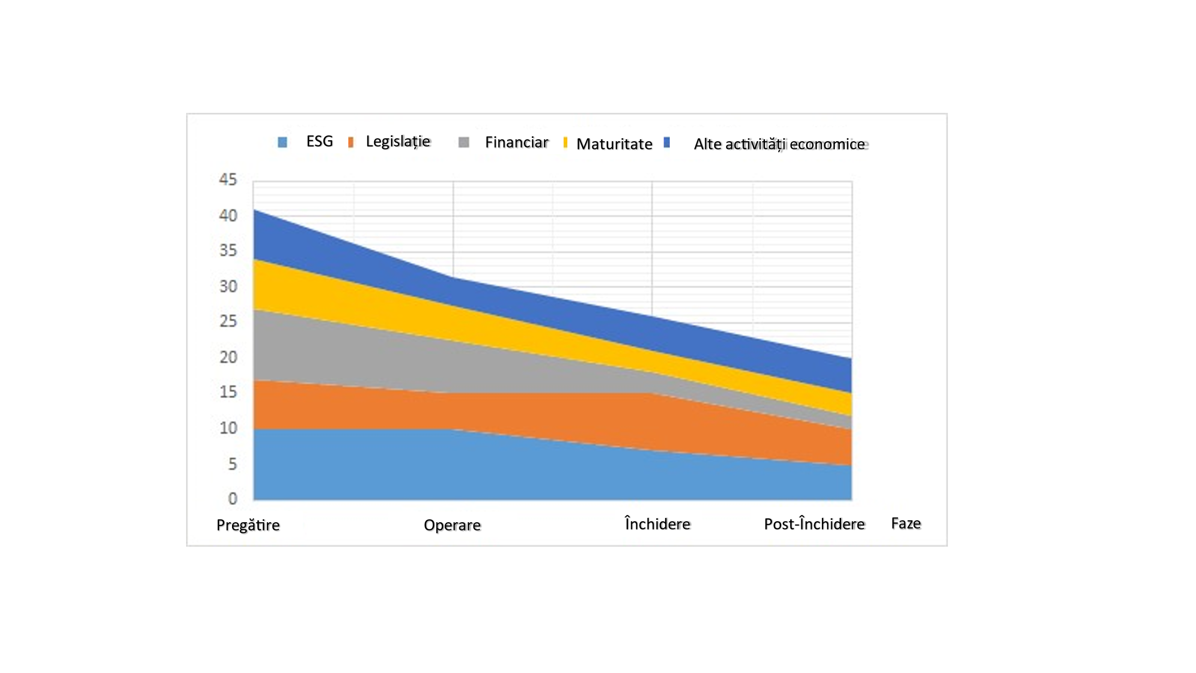

**Figure 2. The importance of different criteria in relation to each other and the change in the overall importance during the different stages of maturation.**

As the aim of the project is to analyse the technico-economic aspects of direct injection through by ship, we have selected the criteria that favour the applicability of the technology. These are presented below, and are specific to each component of the CCS value chain**.**

**The selection criteria for the capture:**

* **Supply logistics**: The location should be within 50 km of the existing ports with good connectivity or at least there should be a clear possibility of establishing such a connectivity. The navigation distance between the port and the storage site is not a selection criterion in itself, but is part of the optimization of the value chain, where injection, navigation and loading must be balanced.
* **CO2 value**: An important criterion, where negative emissions are preferred.
* **Future Scenarios**: An essential criterion is the consideration of long-term plans of the emitters and the existence of CCS plans. This is where facilities with long-term sustainable operating plans are preferred.
* **Reliability of supply and volume**: Will not be used as selection criteria. The flexibility of direct injection by ship can benefit players who are often left out of consideration. The supply volume can then be used in value chain optimization in the form of captured CO2 cost. Furthermore, flexibility in vessel design could help engage small emitters.

In regions where there is a wide selection of potential emitters, a spider diagram of the above criteria can be applied to pre-select and narrow down the list of potential candidates for the scenario evaluation.

**The selection criteria for the storage:**

* **Storage Readiness Level (SRL)**: A criterion that includes both the technical status and the permissions of the storage site. An SRL of at least 3 is preferred (the screening identifying the individual site and storage concept).
* **Access to storage:** It represents the initial estimates of ease of access in terms of water depth, distance, existing infrastructure and preliminary cost assessment.
* **Overlapping with other economic activities:** May form part of the storage access category, including traffic and other economic activities.
* **Other factors:** Including salinity, gas-hydrate formation risks and other factors specific to the operating area.

The individual factors in each criterion, for example salinity and gas hydrate formation risks, can be weighted differently to be later combined into an overall factor score between 0 and 1.The four categories (SRL, storage access, overlapping, other factors) can then be plotted together on a spider chart to select the storage sites. Further selection can be made as part of the scenarios assessment based on storage costs and balancing emissions with storage capacity.

**1.1. Selection of candidates in different geographical areas and creation of scenarios (I) - Definition of the preliminary Romanian scenario for the implementation of CO2 injection technology directly by ship**

Applying the selection criteria presented above, we started the selection process of the Romanian case study, the CCS value chain. Within the CTS project, we selected for the Romanian scenario the emitters with firm decarbonization plans and with stable operations from Constanța and Călărași.

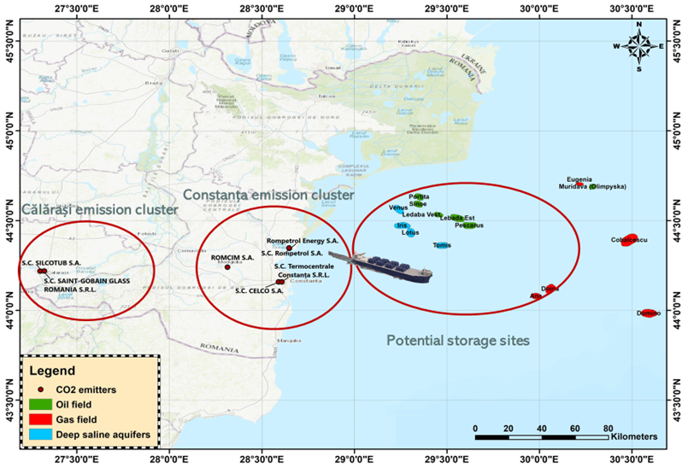

**Figure 3. Emitters and potential storage sites within the Romanian scenario**

Within the Călăraşi cluster, we selected 2 transmitters, S.C. SILCOTUB S.A. Călărași workplace, steel producer and S.C. SAINT - GOBAIN GLASS ROMANIA S.R.L., glass manufacturer.

The Constanța cluster consists of 5 emitters, Romcim Medgidia (cement industry), S.C. CELCO S.A. (construction materials industry), S.C. Termocentrale Constanta S.R.L. (former CTE Palas, thermal energy industry), S.C. Rompetrol Rafinare S.A. - work point Petromidia (refinery) and Rompetrol Energy S.A. (former UT Midia, electricity production industry).

As potential storage sites we selected the offshore sites, depleted or depleting oil and gas deposits – Sinoe, Lebăda Est, Lebăda Vest – and a few potential saline aquifers identified among the structures explored and proven non-productive in the 1980s – Venus, Iris , Tomis, Lotus.

The transport choice is of multi-modal type, assuming river transport (on the Danube and the Danube-Black Sea canal), pipeline transport from emitters to ports and maritime transport via pipelines, traditional ships and direct injection ships. The ports of interest are Călărași, Agigea-Constanța Sud and Midia-Năvodari.

**The Romanian scenario**, taking into account the selected emitters and sites, involves the following three options:

**Option 1**. The CO2 captured from the selected industrial plants in Calarasi will be transported by short pipelines to the port of Calarasi, from where it will be loaded on barges and will be transported on the Danube and the Danube-Black Sea channel to a hub in the Midia-Navodari port.The CO2 captured from the Constanța cluster, including Medgidia, will be transported through short pipelines to the Midia-Năvodari hub. From there, it will be loaded and transported through a pipeline that will follow the corridor of the current pipeline that transports hydrocarbons from the offshore fields. The pipeline will connect to a platform from which the CO2 will be distributed through smaller pipelines to the selected storage sites.

**Option 2**. The CO2 captured from the selected industrial plants in Calarasi will be transported by short pipelines to the port of Calarasi, from where it will be loaded on barges and will be transported on the Danube and the Danube-Black Sea channel to a hub in the Midia-Navodari port. The CO2 captured from the Constanța cluster, including Medgidia, will be transported through short pipelines to a hub in Agigea-Constanța Sud port. From there, it will be loaded into containers and transported by conventional ships to the offshore storage sites.

**Option 3**. The CO2 captured from the selected industrial plants in Calarasi will be transported by short pipelines to the port of Calarasi, from where it will be loaded on barges and will be transported on the Danube and the Danube-Black Sea channel to a hub in the Midia-Navodari port. The CO2 captured from the Constanța cluster, including Medgidia, will be transported through short pipelines to a hub in Agigea-Constanța Sud port. From there, it will be loaded onto the NEMO ship (direct injection ship) and directly injected into the offshore sites.

For each variant, a technico-economic analysis will be made, and then a comparison meant to analyze the feasibility of implementing direct injection technology compared to the traditional methods of transport and injection.

**1.1. Analysis of CCS value chains in different geographical areas (I) - Preliminary analysis of the selected carbon capture and storage value chain for Romania**

For the analysis of the carbon capture and storage value chain selected for Romania, consisting of the Calarasi and Constanta emission clusters, multi-modal transport and storage in the Black Sea, the exclusive economic area of Romania, in depleted deposits of saline hydrocarbons and aquifers, for each component, the database of the project, whose structure was made by NORCE partners and Universidade Evora, was populated with the data necessary for the technicoo-economic analysis that will be done next year. Furthermore, based on the collected data, a preliminary analysis was made on each component of the CCS value chain.

**1.1.** **End-user engagement analysis (I) - End-user mapping in Romania**

The analysis of end-user engagement is carried out in the CTS project through a series of tools (work package 5) and had started with end-user mapping. For this activity, the regional teams identified relevant stakeholders for the application of shipboard direct injection technology based on their own experience (eg, ongoing and past projects and activities) and past interactions.

For each region, the following stakeholder categories are listed: the emitters, the potential storage operators (hydrocarbon field operators), the port operators/authorities, the representatives of the Competent Authority for geological CO2 storage, NGOs. GeoEcoMar coordinated this activity and the creation of the related report. GeoEcoMar also carried out the mapping of end users in Romania, analyzing the legislative framework related to the implementation of CCS.

Romania has a target of reducing greenhouse gas (GHG) emissions by 85% by 2030, compared to 1990 levels, with sector-specific purposes. As a regulation, Romania has Directive 2009/31/EC for the geological storage of CO2, transposed by Law 114/2013, with the competent authority being the National Authority for Energy Regulations, Carbon Dioxide Oil and Storage (ANRMPSG).

Other relevant national authorities are ACROPO (The Competent Regulatory Authority for Offshore Oil Operations in the Black Sea), ANRE (National Energy Regulatory Authority), The Lower Danube River Administration Galati and the Ministry of Environment, Waters and Forests. Among the regional authorities, important stakeholders are the local administrations of Calarasi and Constanta counties, as well as for the ports in the Romanian scenario.

Considering that, for the Romanian scenario, the target regions are Dobrogea (on land) and Histria Depression in the Black Sea, the focal point of the transport infrastructure is the Port of Constanta.

The emitters involved in the scenario are the cement company ROMCIM S.A., the construction materials company CELCO S.A., Termocentrale Constanta (heat energy producer), the Rompetrol Rafinare refinery, the energy producer Rompetrol Energy, the glass producer Saint Gobain Glass Calarasi and the steel plant Silcotub Calarasi.

The potential transport operator is Transgaz, the technical operator of the National Gas Transport System. Potential storage operators are OMV Petrom and Romgaz. The relevant NGOs include CO2 Club Romania, Greenpeace Romania, WWF Romania, the Association for Smart Energy, the Federation of Associations of Energy Utility Companies, COGEN Romania, the Romanian Energy Center, the Romanian Association for Oil Exploration and Production, Oil and Gas Employers' Federation and CIROM, the employer organization of cement and mineral products producers.

All these potential users of the technology will be informed throughout the project and consulted so that next year's techno-economic analysis is as close to reality as possible.

The stakeholder engagement strategy includes dedicated workshops associated with project meetings, dedicated regional consultation meetings and workshops focused on individual scenarios.

As part of the stakeholder engagement strategy, GeoEcoMar also contributed to a questionnaire that aims to verify the interest of stakeholders in the application of direct ship injection technology, as well as in the level of interest and awareness towards CCS (capture and storage carbon). This questionnaire will be implemented next year.

As part of the end-user involvement strategy, GeoEcoMar organized a hybrid workshop on the 14 of November 2024, both wit physical presence of guets at the GeoEcoMar headquarters in Bucharest and online on the Zoom platform. Besides the project team, including the coordinator Roman Berenblyum (NORCE) and Ole Johan Ostvedt (NEMO MARITIME), among the guests, there were representatives of the emitters within the Romanian scenario (ROMCIM Medgidia), representatives of potential storage operators (OMW Petrom), authorities (ANRMPSG) and members of relevant NGOs (CO2Club Romania and World Petroleum Council – Romania Branch).

The first part of the event consisted of technical presentations, the presentation of the project (Roman Berenblyum, NORCE), the presentation of the technology of direct injection on the ship – NEMO solution (Ole Johan Ostvedt, Ole, NEMO MARITIME) and the presentation of the Romanian scenario (Alexandra Dudu, GeoEcoMar). In the second part of the event, there was a question and answer session based on the prior presentations and a round table on the topic of the Romanian scenario. The discussions helped to finalize the Romanian scenario and to inform the users about the technology analyzed in the project.

Project Manager

Dudu Alexandra-Constanța

