**PN23300103: Improving the monitoring program of the Romanian Black Sea shelf in order to increase the capacity to assess and predict the impact of multi-stressors on the marine ecosystem services**

The main objective of the project is to improve the current monitoring program of the Romanian continental shelf, by introducing and developing new monitoring methodologies, in order to increase the capacity to assess and predict the impact of natural and anthropogenic stressors on ecosystem services and, implicitly, on the well-being of coastal communities.

During 2024, two ecosystem services were addressed, namely **Maintenance and regulation by inorganic natural chemical and physical processes** (CICES code: 5.2.2.1) and **Regulation of the chemical condition of salt waters by living processes** (CICES code: 2.2.5.1), both included in the **Chemical conditions of seawater** domain.

In a first stage, the natural and anthropogenic stressors associated with the two ecosystem services were identified and analyzed, in terms of their size/intensity, as well as the risks associated with them. The intensity of these stressors, both natural (temperature rise, changes in precipitation, sea currents, sea level rise, sea acidification, deoxygenation, etc.) and anthropogenic (urbanization, tourism, port activities, industry, agriculture, etc.), as well as the spatial dimension of their action were analyzed either on the basis of the data obtained by NIRD GeoEcoMar in previous projects or by consulting the specialized literature. Next, the main risks (those related to pollution and eutrophication) to which these two ecosystem services are subjected as a result of the cumulative effect of the stressors identified and described above were identified and analyzed.

Another activity carried out in 2024 was to improve the methodology for monitoring the quality of the ecosystem services addressed, by introducing new components in the monitoring program and improving/developing integrated parameters and indicators. Thus, the theoretical and technical foundations were laid, through the acquisition of specific equipment, while at the same time analytical procedures for determining in the laboratory (through ultra-performance liquid chromatography) the priority and emerging organic contaminants were developed.

This activity was completed in July 2024 with the organization of an oceanographic cruise in the Romanian Exclusive Economic Zone waters, onboard the R/V Mare Nigrum, with a total of 37 stations being performed, located at depths between 13 m and 1,116 m (Fig. 1).

During this cruise, in-situ measurements of the physicochemical parameters of seawater (temperature, salinity, dissolved oxygen, fluorescence) were made. Also, water samples were taken for chemical (nutrients, contaminants) and biological (chlorophyll, zooplankton) determinations, samples of sediments for grain-size, geochemical and biological (zoobenthos) determinations and, last but not least, mollusc samples were taken in order to determine the level of their contamination with heavy metals and organic pollutants.

In order to study the chemical conditions of seawater in the cold period, a seawater and sediment sampling campaign was additionally carried out in November 2024 within an oceanographic expedition carried out in another project. In this campaign, in-situ measurements of the physicochemical parameters of a Portița-Sud-Est transect were taken, taking samples from 7 stations with a bottom depth between 13 and 70 m.

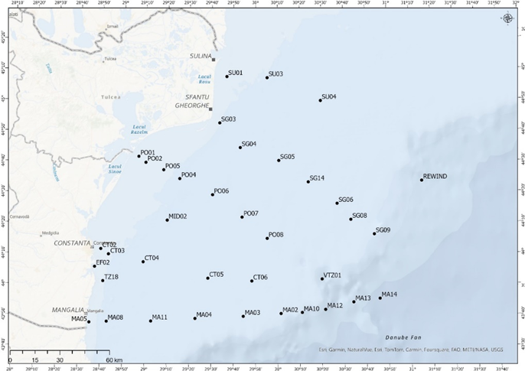

**Fig. 1 Study area (MN 260 cruise, 20.07 – 30.07.2024**

In order to better assess the intensity of the risks generated by pollution, a new methodology for priority and emerging contaminants monitoring was developed using passive sampling tools, adapted according to the classes of contaminants that were considered. The locations where this equipment will be installed have also been partially established, namely in the coastal area, in the Mamaia area (the area for the disposal of treated water from the Constanta North station) and in the ports of Constanta and Mangalia. The proposed sampling methodology was successfully tested for heavy metals and polycyclic aromatic hydrocarbons in the port of Constanta, and will later be used in other anthropized areas (Mangalia port, Mamaia area, etc.).

Given the rather limited level of knowledge regarding the presence of emerging pollutants, the transport mechanism, as well as their effects on the ecosystem, a draft of the Register of Emerging Pollutants on the Romanian coast was started, including information structured on several criteria. This draft form of the Register will be completed in the next phases of the project (new data on emerging contaminants will be acquired).