PN23300201, Contract no. 4N/30.12.2022 PN23300201: Applied research in recent deltaic sedimentary structures in order to highlight/parameterize the accumulations of marine mineral/energy resources

In 2024, the activities were carried out, in accordance with the project implementation plan, as three execution phases.

In the first phase - F4/2024, in order to carry out phase F5 (acquisition of new data within a scientific research expedition), the information obtained in 2023 was synthetized and to be empoyed for planning the works to be done in phase 5 of the project. It was designed and the methodology for the acquisition of multichannel seismic reflection data (by using new equipment, purchased from the previous stages of the core project) was analyzed. Also at this stage, the works (seismic acquisition profiles) for stage F5 were designed.

In the second phase of execution – F5/2024, the research expedition at sea was carried out, which had the unique identifier MN259. On this occasion, more than 1300 km of high and very high resolution seismic profiles were accomplished, with the sub-bottom profiler equipment and the new 12-channel seismic reflection system. Also, during this stage, the documentation at metadata level of the newly acquired information (by processing navigation data) was carried out, information that completed the GIS base of the project.

In the last phase of execution F6/2024, the data acquired during the previous phase of execution, the MN259 research expedition, were processed. As a result of the processing, digital GIS objects were made, as seismic time cross-sections, corresponding to sub-bottom profiler data - SBP; seismic time coross-sections corresponding to the data acquired with the multichannel reflection seismic method; the preliminary interpretation of the new information was carried out, as well as the production of GIS objects resulted from the interpretation of the new data, the normalization and inclusion of these digital objects in the project's GIS database; two actions were undertaken to disseminate the results, first by participating in the international workshop "18th Workshop of the International Lithosphere Program - Task Force Sedimentary Basins 07-11 Oct 2024 Kraków, Poland" and the second one in the "9th edition of the GEOSCIENCE – International Symposium 14-16 November 2024 Bucharest" (at which GeoEcoMar was co-organizer); during the first dissemination action, the project implementation team presented the paper "Shallow methane accumulations on the Romanian continental shelf of the Black Sea", and at the second, the paper "Sedimentary evolution of the northwestern Black Sea shelf area during Pleistocene" Below, is presented an example, of the interpreted seismic cross-section.

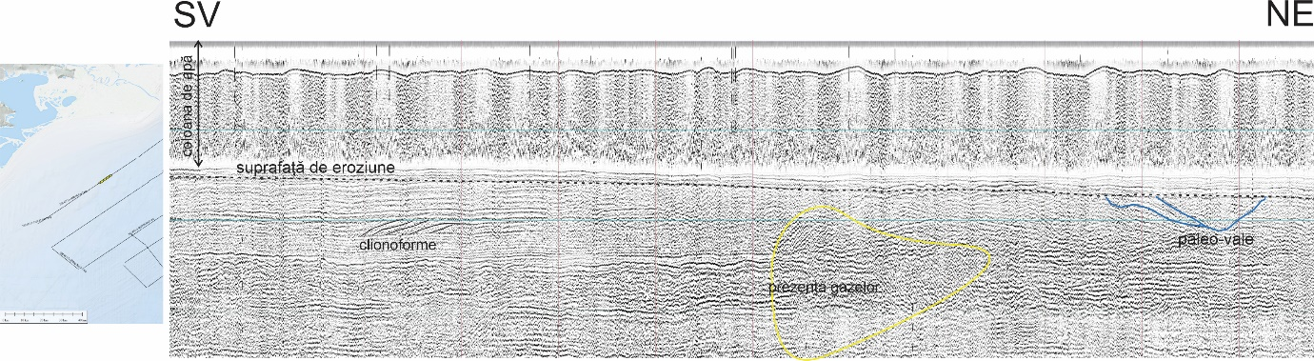

Interpreted seismic time section (multichannel reflection seismic)