**PN 23 30 03 02 - Impact of the anthropogenic and climate changes, vulnerabilities, and adaptation measures to increase resilience in the lakes of the Danube Delta Biosphere Reserve**

**Activities and results obtained due to the implementation of the research project in 2023**

Project aim. This project aims to provide in-depth scientific knowledge and constant monitoring of the environmental changes under the influence of global climate change, as well as natural and anthropogenic factors affecting the Danube Delta, to emphasize the evolution trends, and to acquire programs to prevent, reduce, and subsequently impede the impairment of the environmental conditions and biodiversity in the delta ecosystems.

Current stage of project implementation. **The project's implementation involves a series of execution phases. Three phases have been planned for 2023: the first phase, with a completion deadline of 10.08.2023, the second, with a deadline of 12.10.2023, and the third, with a deadline of 07.12.2023. The progress recorded in the implementation of the project and a brief description of the level of achievement are presented below.**

***Phase 1*** *- Achievement of the complex field activities and laboratory studies and investigations (hydrological, sedimentological, geochemical, biological, topo-hydro-bathymetric, and geophysical) on aquatic ecosystems in the Lopatna-Matița-Merhei Hydrographic Unit, under seasonal variations-spring 2023.*

Objective achievement - Phase 1. The objectives proposed for this phase were fully achieved according to the implementation scheme. Project initiation aimed to establish the main key activities and sub-activities submitted to achieve the expected results. The accomplished activities and sub-activities were: organizing and performing field activities, corroborating interdisciplinary research methods for aquatic ecosystems investigations (hydrological, sedimentological, geochemical, biological, topo-hydro-bathymetric, geophysical), stabilizing methods of sampling and analysis(water, sediments and biota) for the control of levels of certain contaminantsto assess the quality status of the aquatic environment, surveying the seasonal dynamics of the emergent aquatic vegetation from specific deltaic lakes, settling of the hydrodynamic measurement plan in the bifurcation areas of the Danube Delta, performing magnetometric investigations etc.

Activities description - Phase 1. The field research activities implying the objective of this phase - Phase 1, occurred in hydrodynamic conditions of high waters of the Danube River and were performed in fluvial environments in the Danube deltaic plain, in specific control sections located on: the Danube (Mm 43.5), Chilia Branch - Km 115, Tulcea Branch (Mm 42.5); Tulcea Branch (Mm 34), Sf. Gheorghe Branch (km 108), Sulina Branch (Mm 33.5), including as well, the Lopatna-Matița-Merhei inter-distributary area, in the following lakes: Bogdaproste, Nujnic, Șerbata, Rădăcinos (Covaliova), Trei Ozere, Ciorticuț, Rădăcinoasele, Babina, Matița, Merheiul Mic and Merhei.

Acquired results - Phase 1. The specific research activities performed within this stage allowed the realization of the estimated results proposed in the activity plan. The results presented in this phase represent the synthesis of measurements carried out during field campaigns, in situ observations, preliminary laboratory analyses, and further scientific investigations regarding the seasonal dynamics of the ecological state in the investigated aquatic ecosystems (seasonal variations of the investigated environmental indicators that are influenced by both abiotic/physical-chemical and biotic factors) (Fig.1).

Evaluating Goal Achievement and Settled Targets - Phase 1. During this phase, the following aspects were acquired: reviewing the methodology and testing the work protocols necessary to achieve the proposed objectives, implementing the environmental sampling plan (water, sediments and biota) with the investigation of 95 sampling sites (transversal profiles/control sections/stations) located in the area of ​​the two bifurcations of the Danube: Ceatal Izmail and Ceatal Sf. Gheorghe, Sulina Branch (Mm 14), Old Danube River Meander (near Mm 14), respectively, in a series of representative lakes from the Lopatna-Matița- Merhei Hydrographic Unit (Bogdaproste, Nujnic, Șerbata, Rădăcinos, Trei Ozere, Ciorticuț, Rădăcinoasele, Babina, Merhei and L. Matița), measurements of the main physical-chemical indicators in the environmental samples (water and sediments) collected under conditions of seasonal variations, assessment of the surface water and sediment quality according to national and international environment reference standards (i.e., dissolved oxygen concentrations, nutrients, technophilic element levels etc.) (Fig. 1), preliminary analysis of hydrological, sedimentological, topo-hydro-bathymetric, geophysical measurements and data acquired to evaluate the seasonal dynamics of the ecological state in the investigated ecosystems under hydrodynamic conditions of high waters of the Danube, elaboration of the thematic maps related to the aquatic vegetation distribution etc. The data presented are under the expected activities of the project.

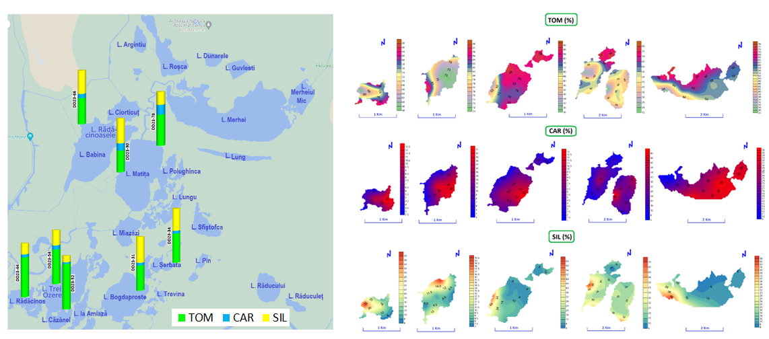Stage of achievement of the planned objective/form of accomplishment - Phase 1. The specific aim of the phase was 100% achieved and fulfilled in the elaboration of the *Interim Report (Phase 1)*.

Fig. 1. Areal and vertical distribution of sediment-specific indicators in the investigated lakes:

total organic matter (%), carbonates (%) and siliciclastic fraction (%)

***Phase 2*** *- Achievement of the complex field activities and laboratory studies and investigations (hydrological, sedimentological, geochemical, biological, topo-hydro-bathymetric, and geophysical) on aquatic ecosystems in the Lopatna-Matița-Merhei Hydrographic Unit, under seasonal variations-autumn 2023.*

Objective achievement - Phase 2. The objectives proposed for this phase were fully achieved according to the implementation scheme. This phase aimed to establish the main key activities and sub-activities submitted to achieve the expected results. The accomplished activities and sub-activities were: organizing and performing field activities, corroborating interdisciplinary research methods for aquatic ecosystems investigations (hydrological, sedimentological, geochemical, biological, topo-hydro-bathymetric, geophysical), stabilizing methods of sampling and analysis(water, sediments and biota) for the control of levels of certain contaminantsto assess the quality status of the aquatic environment, surveying the seasonal dynamics of the emergent aquatic vegetation from specific deltaic lakes, settling of the hydrodynamic measurement plan in the bifurcation areas of the Danube Delta, performing magnetometric investigations etc.

Activities description - Phase 2. The field research activities implying the objective of this phase - Phase 2, occurred in hydrodynamic conditions of low waters of the Danube River and were performed in fluvial environments in the Danube deltaic plain, in specific control sections located on: the Danube (Mm 43.5), Chilia Branch - Km 115, Tulcea Branch (Mm 42.5); Tulcea Branch (Mm 34), Sf. Gheorghe Branch (km 108), Sulina Branch (Mm 33.5), Sulina Branch (Mm 14), Old Danube River Meander (near Mm 14) including as well, the Lopatna-Matița-Merhei inter-distributary area, in the following lakes: Bogdaproste, Nujnic, Smioniva, Șerbata, Căzănel, Trei Ozere, Rădăcinos, La Amiază, Miazăzi, Matița, Vastojnaia, Merhei, Merheiul Mic, Ciorticuț, Rădăcinoasele and Babina.

Acquired results - Phase 2. The specific research activities performed within this stage allowed the realization of the estimated results proposed in the activity plan. The results presented in this phase represent the synthesis of measurements carried out during field campaigns, in situ observations, preliminary laboratory analyses, and further scientific investigations regarding the seasonal dynamics of the ecological state in the investigated aquatic ecosystems (seasonal variations of the investigated environmental indicators that are influenced by both abiotic/physical-chemical and biotic factors).

Evaluating Goal Achievement and Settled Targets - Phase 2. During this phase, the following aspects were acquired: reviewing the methodology and testing the work protocols necessary to achieve the proposed objectives, implementing the environmental sampling plan (water, sediments and biota) with the investigation of 130 sampling sites (transversal profiles/control sections/stations) located in the area of ​​the two bifurcations of the Danube: Ceatal Izmail and Ceatal Sf. Gheorghe, Sulina Branch (Mm 14), Old Danube River Meander (near Mm 14), respectively, in a series of representative lakes from the Lopatna-Matița- Merhei Hydrographic Unit (Bogdaproste, Nujnic, Smioniva, Șerbata, Căzănel, Trei Ozere, Rădăcinos, La Amiază, Miazăzi, Matița, Vastojnaia, Merhei, Merheiul Mic, Ciorticuț, Rădăcinoasele and Babina), measurements of the main physical-chemical indicators in the environmental samples (water and sediments) collected under conditions of seasonal variations, assessment of the surface water and sediment quality according to national and international environment reference standards (i.e., dissolved oxygen concentrations, nutrients, technophilic element levels etc.), preliminary analysis of hydrological, sedimentological, topo-hydro-bathymetric, geophysical measurements and data acquired to evaluate the seasonal dynamics of the ecological state in the investigated ecosystems under hydrodynamic conditions of low waters of the Danube, elaboration of the thematic maps related to the aquatic vegetation distribution etc. The data presented are under the expected activities of the project.

Stage of achievement of the planned objective/form of accomplishment - Phase 2. The specific aim of the phase was 100% achieved and fulfilled in the elaboration of the *Interim Report (Phase 2)*.

***Phase 3*** *– Integrated analysis of multiple acquired data regarding the seasonal dynamics and the evolution of the environmental indicators investigated within deltaic aquatic ecosystems during 2023*.

Objective achievement - Phase 3. The objectives proposed for this stage were fully achieved according to the implementation plan. In this phase (Phase 3) of the research project, an integrated analysis of the data obtained on the seasonal dynamics and evolution of the environmental indicators investigated in the aquatic ecosystems considered in 2023 was carried out, to identify, analyze and assess potential risks with different impacts on the quality of the ecosystems investigated in the bifurcation areas of the Danube Delta (Ceatal Izmail and Ceatal Sf. Gheorghe) (Fig. 2), including the Lopatna-Matița-Merhei Hydrographic Unit.

Activities description - Phase 3. The specific research activities that represent the subject of this phase - Phase 3, were fulfilled according to the programming and goals defined in the project.

Acquired results - Phase 3. The specific research activities performed within this stage allowed the realization of the estimated results proposed in the activity plan. The results presented in this phase represent the synthesis of measurements carried out during field campaigns, in situ observations, preliminary laboratory analyses, and further scientific investigations regarding the seasonal dynamics of the ecological state in the investigated aquatic ecosystems (seasonal variations of the investigated environmental indicators that are influenced by both abiotic/physical-chemical and biotic factors).

Evaluating Goal Achievement and Settled Targets - Phase 3. By the whole of the project's targets and performance indicators, the following are mentioned: applying 10 methodologies/protocols for assessing the quality status of water, sediments, and biota, including quantification of morphological changes in the Danube riverbed and mapping of the contours of the investigated lakes; investigation of 18 control cross-sections at the Danube bifurcations, as well as, a total number of 15 lakes; elaboration of 3 technical-scientific reports; assessment of the quality status of the investigated ecosystems. The data presented are in line with the expected activities of the project.

Stage of achievement of the planned objective/form of accomplishment - Phase 3. The specific aim of the phase was 100% achieved and fulfilled in the form of the preparation of the *Final Report 2023 (Phase 3)*.

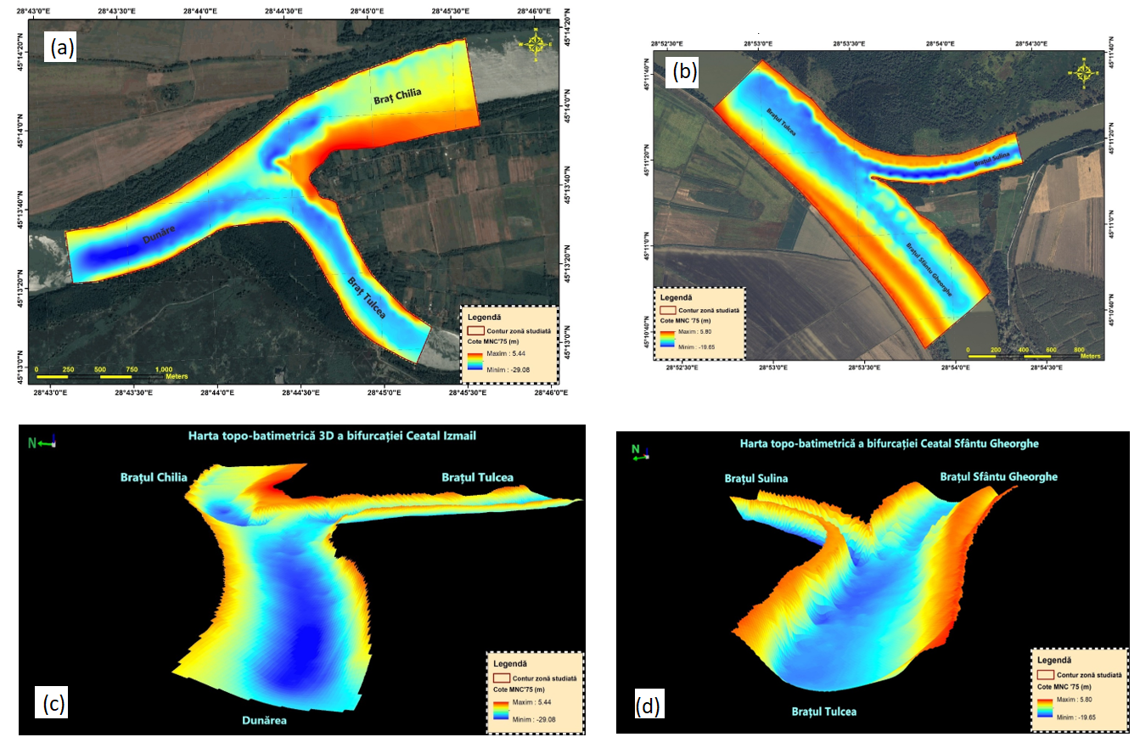

Fig. 2. Topo-bathymetric map at Ceatal Izmail and Ceatal Sfântu Gheorghe bifurcations

Dissemination of project results. The activity of revaluation and dissemination of the project outcomes, in the function of the current acquired results, was expressed as participation in national/international conferences, including the publication of scientific research papers in national and international scientific journals.

Research equipment purchased in 2023. This year, the following essential articles were purchased: a real-time sound speed sensor (Teledyne Marine SVP70, compatible with Ecosondor) and a graphics workstation.