**Project PN 23 30 04 01:** Monitoring and evaluation of protected natural areas in UNESCO Geoparks and Aspiring Geoparks in Romania and development of a Citizen Science platform

**Phase: 3:** Monitoring of natural reserves and evaluation of geosites and archaeological sites on the territory of the UNESCO Buzău Land Geopark.

Buzău Land Geopark is a sustainable development territory located in the Carpathian bend area, at the transition between hills and mountains. It is a completely rural territory that extends over an area of ​​almost 1036 km2 and coincides with the administrative boundaries of 18 communes.

The geodiversity of this territory is linked to salt and saliferous formations, amber, volcanic tuffs, mud volcanoes and live fires (the result of the degradation of hydrocarbon deposits), salt springs, mineral and fuel oil springs, but also to erosion phenomena that have created very picturesque reliefs and landscapes on the sandy rocks of the sandstone, clay and disodilic schist successions. Based on these types of rocks and phenomena, several natural reserves were established, according to law 5/2000: Buzău Salt, Meledic Plateau, Bădila Limestone Blocks, Piatra Alba "La Grunj", Păclele Mari Mud Volcanoes, Păclele Mici Mud Volcanoes, Terca Live Fire.

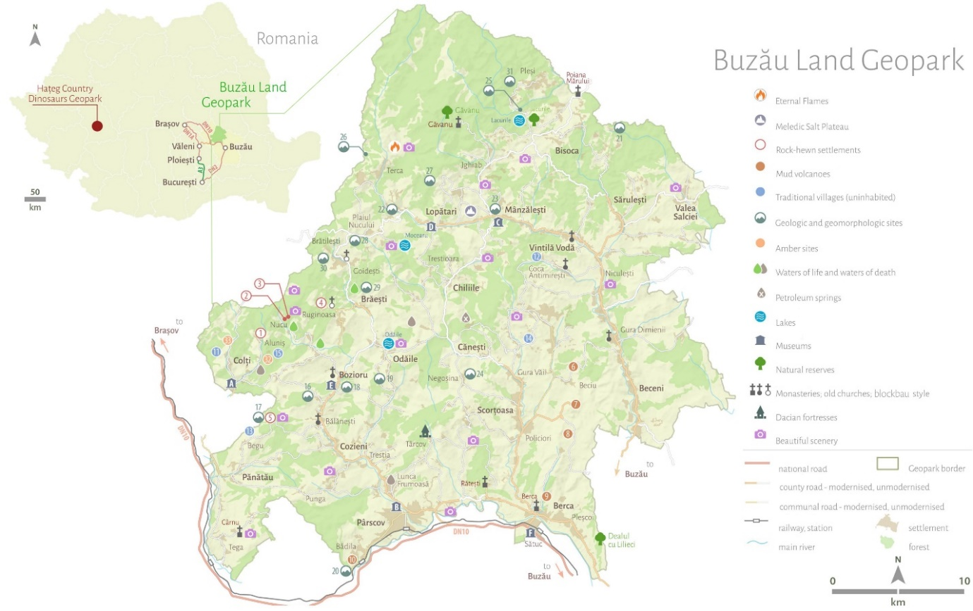

Touristic map of the Buzău Land Geopark (source <https://tinutulbuzaului.org/>).

For the monitoring of natural reserves and the evaluation of geosites and archaeological sites on the territory of the UNESCO Buzău Land Geopark, the following locations were investigated:

Buzău Amber (Colți village area)

Buzău Amber (near Colți village) is a protected area of ​​national interest located in the Curvature Carpathians area – corresponding to IUCN category III (geological and paleontological nature reserve, natural monument), located in Buzău county on the administrative territory of Colți commune.

Buzău Salt

Buzău Salt is a protected area of ​​national interest corresponding to IUCN category III (geological and botanical natural reserve, natural monument) located 2 km west of the village of Bădila.

The reserve includes 1.77 ha with saline springs and salt efflorescence.

The Bădila Limestone Blocks

The Bădila Limestone Blocks are a protected area of ​​national interest corresponding to IUCN category III (geological and paleontological nature reserve), located in Buzău County. It was declared a protected area by Law no. 5 of 6 March 2000 (on the approval of the National Land Development Plan - Section III - protected areas), with a protected area of ​​3.02 hectares. The conglomerate blocks with a thickness of the order of meters are composed of green shale and limestone elements. They outcrop on the left bank of the Buzău River.

The Ulmet Trovant – The ‘Babele’ of Ulmet

This site is located in the central part of the Buzău Land Geopark. It is already a well-known tourist attraction, but has not been included in the list of natural reserves in Romania so far. The site is also described as the Babele of Ulmet. This geosite is characterized by the spectacular appearance of trovant, of various shapes, arranged in several alignments.

Mineral springs in Fişici

Until 1990, the town was known as a spa resort due to its mineral-rich springs with curative properties. Today, the spa facilities, including the sanatorium, are almost completely damaged. The mineral springs are located near the bed of the Gârla Fişici stream, upstream and downstream of the parking lot in the town.

Mud volcanoes at Pâclele Mici and Pâclele Mari

Mud volcanoes are formations created by natural gases coming from over 3,000 meters deep, which pass through a clay soil in combination with water from the groundwater. The gases push the water mixed with clay to the surface.

Beciu Mud Volcanoes

The site is located at an altitude of 280 m and has an area of ​​approximately 20x40 m. Compared to the Big and Small Mud Volcanoes, the Beciu Mud Volcanoes occupy a smaller area, but their activity is more intense.

Mud volcanoes “La Fierbători”

They are distinguished from other volcanic occurrences in the area by the large amount of fluid hydrocarbons (crude oil) that appear on the surface, along with gaseous ones (especially methane), which are also common in other areas with volcanoes located on the Berca-Arbănași structure. Cones with a diameter of 1-1.5 m, filled with fuel oil and mud.

Lopătari Live Fire

The Lopătari Live Fire - a protected area of ​​national interest, category III IUCN (natural monument), is located on the administrative territory of the Lopătari commune, Terca village. The site is located, from a geological point of view, in the Tarcău Plain, in the area where Eocene deposits outcrop, in the NW part of the geopark, on the western slope of the Brezău Peak, at an altitude of 1030 m. The live fire is a natural phenomenon due to the emanation of natural gases that come to the surface, the gases being predominantly made up of methane (approximately 80%), the rest being represented by carbon dioxide.

Meledic Plateau and Salt Mountain

The Meledic Plateau is a protected area of ​​national interest corresponding to IUCN category IV (mixed geological, speleological, botanical and zoological natural reserve), on an area of ​​67.50 ha, located on the administrative territory of the Lopătari and Mânzălești communes.

White Stone “La Grunj”

The white stone “La Grunj” is a Badenian volcanic tuff (Middle Miocene, approx. 15 million years ago) is volcanic material (ash), resedimented in the marine environment, a fact attested by the presence of marine organisms (foraminifera, e.g. globigerina and calcareous marine algae, e.g. calcareous nannoplankton), as well as the stratification. It is a geological natural reserve, category III IUCN (natural monument).

A number of 12 sheets for geological reserves and sites were prepared. In addition, inventories of various types of geological heritage were prepared.

A Workshop and a Summer School were held in Berca, in the UNESCO Buzău Land Geopark. The summer school was held in the UNESCO Buzău Land International Geopark, between 14-17 May 2024, in Berca. During three days of activities, both field campaigns were carried out in various points of interest in the Buzău Land Geopark, to present geological and geo-ecological aspects, as well as a series of scientific communications.

Phase 4: Monitoring of natural reserves and evaluation of geosites and archaeological sites within the territory of the Carpaterra Geopark.

The Carpaterra Geopark is a sustainable development territory created in the form of a partnership between city halls, educational institutions and NGOs. It has an area of ​​27099.59 km2, and extends over the territory of the localities of Racoș, Mateiaș, Homorod, Mercheașa, Rupea Gară, Jimbor, Fișer and Rupea.

The mission of the Carpaterra Geopark is the development of a community from an educational, touristic and socio-cultural point of view, applying the values ​​of the UNESCO international geoparks and entering the UNESCO Global Geoparks network.

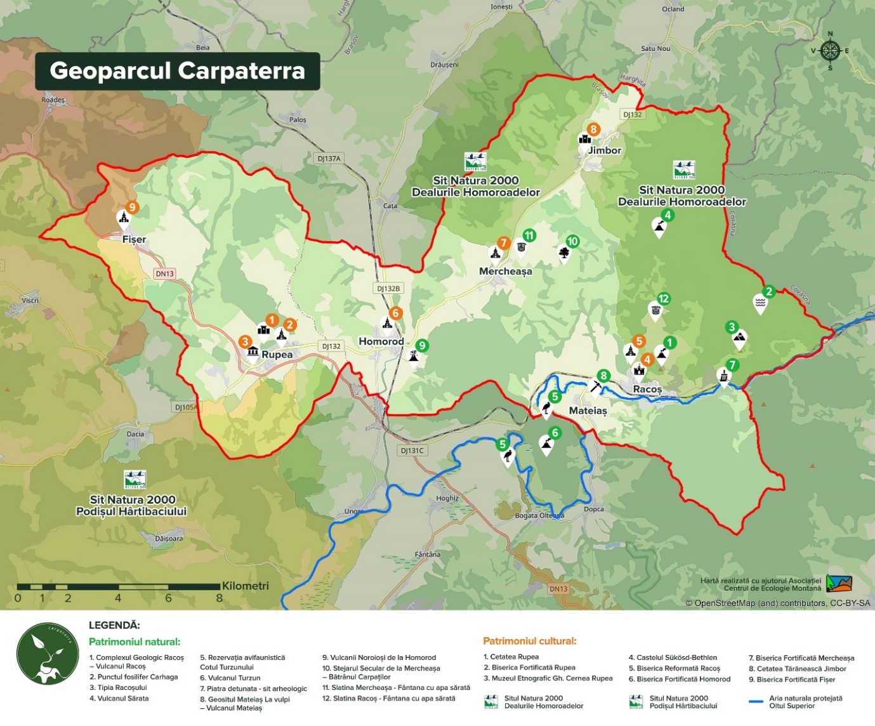

Map of the Carpaterra Geopark (source <http://www.carpaterra.org/ro>).

For the monitoring of natural reserves and the evaluation of geosites and archaeological sites on the territory of the Carpaterra Geopark, the following locations were investigated: Nature Reserve 2,485 Vârghiș Gorges and Caves in Gorges, Racoșul de Jos Geological Complex, Racoș Basalt Columns, Brazi Basalt Quarry (Brazi Geosite and Emerald Lake), Hegyes Hill Basalt Slag Quarry (Extinct Volcano on Hegheș Hill), Basalt Microcanyon from Hoghiz, Mateiaș Geosite at Vulpi, Basalt Rock from Rupea, Mud Volcanoes from Băile Homorod.

For the Carpaterra Geopark, 10 sheets were produced for reservations and geosites and 2 for archaeological sites and historical monuments. Summer school entitled Training Camp for Young Ambassadors of the Geopark Network in Romania – Murighiol, 26-29.08.2024, on the territory of the Cimmerian Dobrogea Geopark was organized.

In the last week of August, volunteers for the Geopark participated in the Training Camp for Young Ambassadors from Romanian Geoparks, of which we were co-organizers. The event brought together 28 of the best and most involved young people from the UNESCO Haţeg County International Geopark and Buzău Land Geopark, from the UNESCO Aspiring Geopark Oltenia under the Mountain and the Carpaterra Geopark project. The volunteers were accompanied by two people from each of the participating geopark teams.

An exhibition module entitled "The Natural and Cultural Heritage of the Cimmerian Dobrogea Geopark" was created, the module which included a number of 25 materials selected from the workshops with children of grades I-IV organized in 2024 (drawings of the Romanian peony, drawings and models of ammonites made of plasticine and clay, drawings of traditional Romanian folk motifs from Tulcea County).