**Project: High-resolution geophysical research for spatio-temporal monitoring of hydrocarbon and wastewater contamination in the PETROMIDIA refinery and CONSTANTA port – OIL TERMINAL area**

**Project Objective**

The primary aim of this project is to implement a geophysical monitoring program for spatio-temporal contamination caused by hydrocarbons and/or wastewater resulting from refining, storage, and transport activities of petroleum products in the PETROMIDIA refinery area and CONSTANTA Port – Oil Terminal zone.The results will provide institutions with valuable data for the protection and conservation of aquifer systems and for the development of a rapid and effective methodology to investigate areas polluted by hydrocarbons and/or wastewater.

The project seeks to develop an integrated solution to enable the early identification of vulnerable areas, thereby mitigating the risks associated with environmental contamination. Additionally, the proposed approach has the potential to be expanded and adapted to other regions impacted by similar industrial activities, fostering best practices for sustainable groundwater resource management.

**1.** **Description of Phases for 2024**

*Phase 3.1: Acquisition and processing of hydrogeological data in the area of the PETROMIDIA refinery*

*Objective of the Phase:*The integration of hydrogeological and geophysical data involved geophysical monitoring through geoelectrical measurements to determine variations in geophysical parameters caused by changes in the spatial distribution and contamination gradient.Soil and water samples were collected from boreholes adjacent to the PETROMIDIA refinery to assess contamination levels.

Differential inversion was studied to develop the hydrogeophysical model of hydrocarbon contamination plumes. To investigate potential pollution sources near the refinery, magnetometric measurements using a cesium gradient meter (Geometrics 864) with continuous measurement and real-time GPS positioning were conducted. These aimed to detect damaged pipelines or buried metal tanks.

*Activities Performed:*

The investigations conducted aimed at monitoring the contamination of the groundwater in the vicinity of the Petromidia refinery through detailed hydrogeological and magnetometric measurements.The hydrogeological determinations carried out in may 2024 included measuring the depth of the groundwater's hydrostatic level and collecting soil samples to identify hydrocarbon pollution. The petroleum pollutant was detected in the form of thin films or in the saturated zone, primarily in the boreholes F1-F5.

Magnetometric measurements revealed buried metallic structures, such as pipelines, which could serve as contamination sources. Detailed maps of the variation in the horizontal magnetic field gradient were created for two areas in the western perimeter of the refinery using a high-precision magnetometer (Geometrics G864). The detected anomalies were correlated with artificial structures, thereby increasing the risk of environmental contamination (Fig. 1).

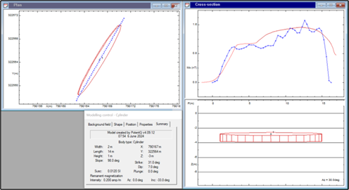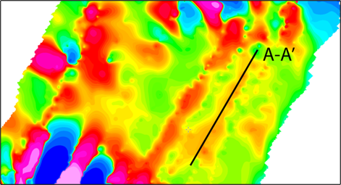

Fig. 1: Modeling of the maximum magnetic anomaly corresponding to the map of the variation in the horizontal magnetic field gradient - Perimeter I.

The research results highlight an area with minimal pollution, concentrated towards the southwest, extending to Lake Tașaul. It is recommended to continue monitoring in order to minimize the risk of pollution, particularly of groundwater resources. As a general conclusion, hydrocarbon contamination in the Petromidia refinery area is influenced by active infiltration processes of surface and industrial waters, amplified by the presence of a system of superficial faults and zones with weakly compacted geological formations. The observed variations in contamination are correlated with changes in humidity and precipitation levels. Detailed studies have identified both historical and current pipelines, underscoring the need to include them in the environmental authorities' records to prevent the risk of further leaks and contamination of the groundwater table.

*Phase 3.2: Geoelectrical and ground penetrating radar (gpr) monitoring of the area surrounding the PETROMIDIA refinery for the purpose of integrating hydrogeological and geophysical data*

*Objective of the Phase:* The integrated hydrogeophysical study aims to monitor and assess the extent and evolution of the contamination plume in a polluted area by correlating hydrogeological and geophysical data obtained from geoelectrical and ground penetrating radar (GPR) measurements carried out in consecutive stages. These data will be used to develop a preliminary hydrogeophysical model that highlights the spatial distribution and direction of contamination, contributing to the development of effective remediation strategies.

*Activities Performed:*

The interpretation of vertical electrical sounding (VES) curves for the Petromidia refinery area involved testing various interpretation methods, aiming to select the optimal solution compatible with the geological structure and the characteristics of hydrocarbon contamination plumes. The interpretation was carried out using EarthImager 2D and 3D software to minimize errors and obtain realistic geoelectrical layering models.

The correlation of VES data with ground penetrating radar (GPR) investigations highlighted local contamination, determined by historical hydrocarbon pollution (Fig. 2). Data collected across three perimeters indicated increased resistivity associated with hydrocarbons at depth, confirming contamination without impacting the groundwater table. GPR surveys, conducted with 100 MHz and 500 MHz antennas, identified notable anomalies related to the presence of pollutants in the soil. The overlap of GPR anomalies with resistivity measurements allowed for the mapping of contamination migration direction, emphasizing the importance of fault zones for pollutant migration. The integration of geophysical, geological, and hydrogeological data led to the development of a preliminary hydrogeophysical model, providing a detailed picture of the geological structure and contamination distribution. This model serves as a basis for planning future monitoring and remediation actions. The preliminary hydrogeophysical model highlights a superficial clay layer, followed by contaminated silty sands and an underlying impermeable clay layer.

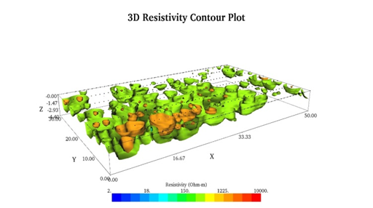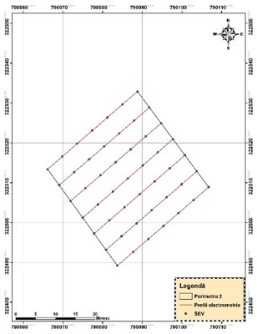

Fig. 2: 3D Representation of the Variation in Apparent Resistivity

This model serves as a foundation for planning future monitoring and remediation actions. The preliminary hydrogeophysical model highlights a superficial clay layer, followed by contaminated silty sands, and an underlying impermeable clay layer.

The aquifer, located at a depth of 2 meters, is characterized by minor petroleum contamination and superficial faults that influence the distribution of pollution. Hydrogeological investigations through boreholes revealed thin hydrocarbon films located above the groundwater level, with contamination confined to stratigraphic contact zones. The investigation results suggest temporal variations in contamination, influenced by precipitation and the continuous influx of pollutants from the refinery.Maximum electrical resistivity anomalies associated with contamination emphasize the importance of continuous monitoring and the correlation of geophysical methods for the precise delineation of affected areas. The aquifer in the Petromidia refinery area is deeply influenced by a complex system of active faults and microfaults oriented NW-SE. These tectonic structures segment and vertically displace the aquifer, creating preferential migration pathways for potential contaminants.

*Phase 4: Geophysical and hydrogeological monitoring in the vicinity of the PETROMIDIA refinery*

*Objective of the Phase:*The main objective of this phase is to evaluate in detail the extent of hydrocarbon contamination in the areas surrounding the Petromidia refinery, through an integrated approach that combines advanced geophysical methods and hydrogeological drilling.

This includes conducting additional boreholes for sample collection and analysis, expanding geophysical measurements (electrometric and ground penetrating radar) in the affected perimeters, especially under conditions of intense precipitation, and integrating the obtained data with results from previous phases. The final goal is to develop a comprehensive and precise hydrogeophysical model of contamination, which will provide a detailed understanding of the distribution and extent of pollution in the area.

*Activities Performed:*

The development of a complex hydrogeophysical model for hydrocarbon contamination involves the integration of geophysical, hydrogeological, and chemical data to create a detailed and accurate picture of contaminant distribution. The process includes data collection through methods such as drilling, electrometry, ground penetrating radar (GPR), and chemical analysis, which are correlated to generate conceptual and numerical 3D models.

These models are validated by comparing them with real data and making iterative adjustments to ensure accuracy. In the Petromidia area, the complexity of industrial operations and their interaction with marine ecosystems necessitate the inclusion of historical contamination, the diversity of hydrocarbons, and climate risks in dynamic simulations. The integrated model includes detailed sections of the stratigraphic structure and contaminant migration, highlighting potential vulnerable zones and contributing to ecosystem protection. Advanced geophysical methods, such as VES and GPR (Fig. 3), have identified hydrocarbon accumulation zones, correlated with sandy stratigraphy and local hydraulic gradient.

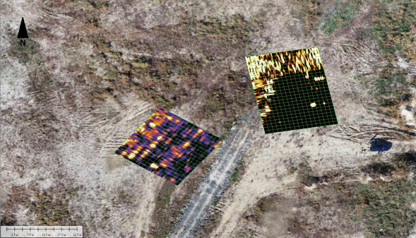

Fig. 3: Ground Penetrating Radar (GPR) Depth Section - 2 m - Perimeters III-IV

The results, validated through drilling, confirmed the migration of contaminants towards the southeast, affecting the surrounding ecosystems. The integration of geophysical investigation data, photogrammetry for topographic details, and predictive simulations contributes to the development of sustainable ecological management, offering effective environmental protection solutions. In conclusion, the hydrogeophysical model clearly highlights localized and low-intensity contamination in Perimeters IV and V, providing a solid foundation for the precise delineation of potentially affected areas.

The integration of geophysical methods (VES, GPR), hydrogeological methods (drilling), and photogrammetric techniques (microrelief analysis and drone mapping) provided a detailed and reliable dataset. This complex approach reduced uncertainties, validated observations, and contributed to the development of a model that correlates underground stratigraphy with surface conditions. The hydrogeophysical model offers clear directions for continuing the project, emphasizing the need for actions such as continuous monitoring of critical areas and expanding investigations in adjacent perimeters. These measures are crucial for environmental protection in the affected areas and for preventing the long-term effects of pollution.

**2. Dissemination: Published Papers, Conference Presentations**

* Title: Environmental Geophysical Diagnosis of a Contaminated Area by Hydrocarbons Using Electrometry Method, Author: Anghel Sorin, Conference: 36th Symposium on the Application of Geophysics to Engineering and Environmental Problems (SAGEEP), Dates: March 23-29, 2024, Location: Tucson, USA, Indexed in: SCOPUS and Google Scholar.
* Title: Detection and Monitoring of Hydrocarbon Pollution Sources in the Petromidia Refinery Area, Author: Anghel Sorin, Conference: The International Conference - Agriculture for Life, Life for Agriculture, Dates: June 6-8, 2024, Location: Bucharest, Romania, Indexed in: Web of Science (Scientific Papers. Series E. Land Reclamation, Earth Observation & Surveying, Environmental Engineering, Vol. XIII, pp. 23-29).
* Title: Utilization of Geophysical Methods in Precision Agriculture and Archaeological Prospection, Author: Anghel Sorin, Conference: The International Conference - Agriculture for Life, Life for Agriculture, Dates: June 6-8, 2024, Location: Bucharest, Romania, Indexed in: Web of Science (Scientific Papers – Series A – Agronomy, pp. 17-24).

**3. Equipment Acquired**

* GNSS System: Trimble R980 with TDC6
* Laptop: Dell Latitude 7330 Rugged CTO